12000 GVWR Low Profile
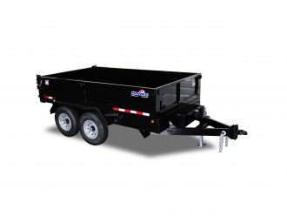
GVWR: 12,000 lb.
Capacity: 8,400 lb.
- Two 6,000 lb. Dexter Brand Braking Axles
- Double Eye Spring Suspension
- 235/80 R16 Load Range E10 Ply Rating Westlake Radial Tires
- 6″ Channel Main Frame – 6″ Channel Tongue
- 3×3 Tubing Dump Box Frame With 3″ Channel Cross Members
- 12 Gauge Floor
- 80″ Inside Box With 24″ Sides And No Stick Bottom Corners
- US Made Pump With Deep Cycle Battery Inside Lockable Security Box With 20′ Hand Remote
- Two Way Tailgate Opens For Dumping Bulk Materials Or Can Be Set In Spreader Mode
- 80″ 3″ Channel Slide-In Loading Ramps
- 2 5/16″ Adjustable Coupler
- 7,000 lb. Drop Foot Jack
- Safety Chains And Break-a-Way Switch
- LED Lighting With Reflective Tape
- Primed with epoxy primer and two coats of polyurethane paint
- AVAILABLE SIZES

Available Sizes
- 80″ x 12′ – Empty Weight 3,400 lb.
- 80″ x 14′ – Empty Weight 3,600 lb.

